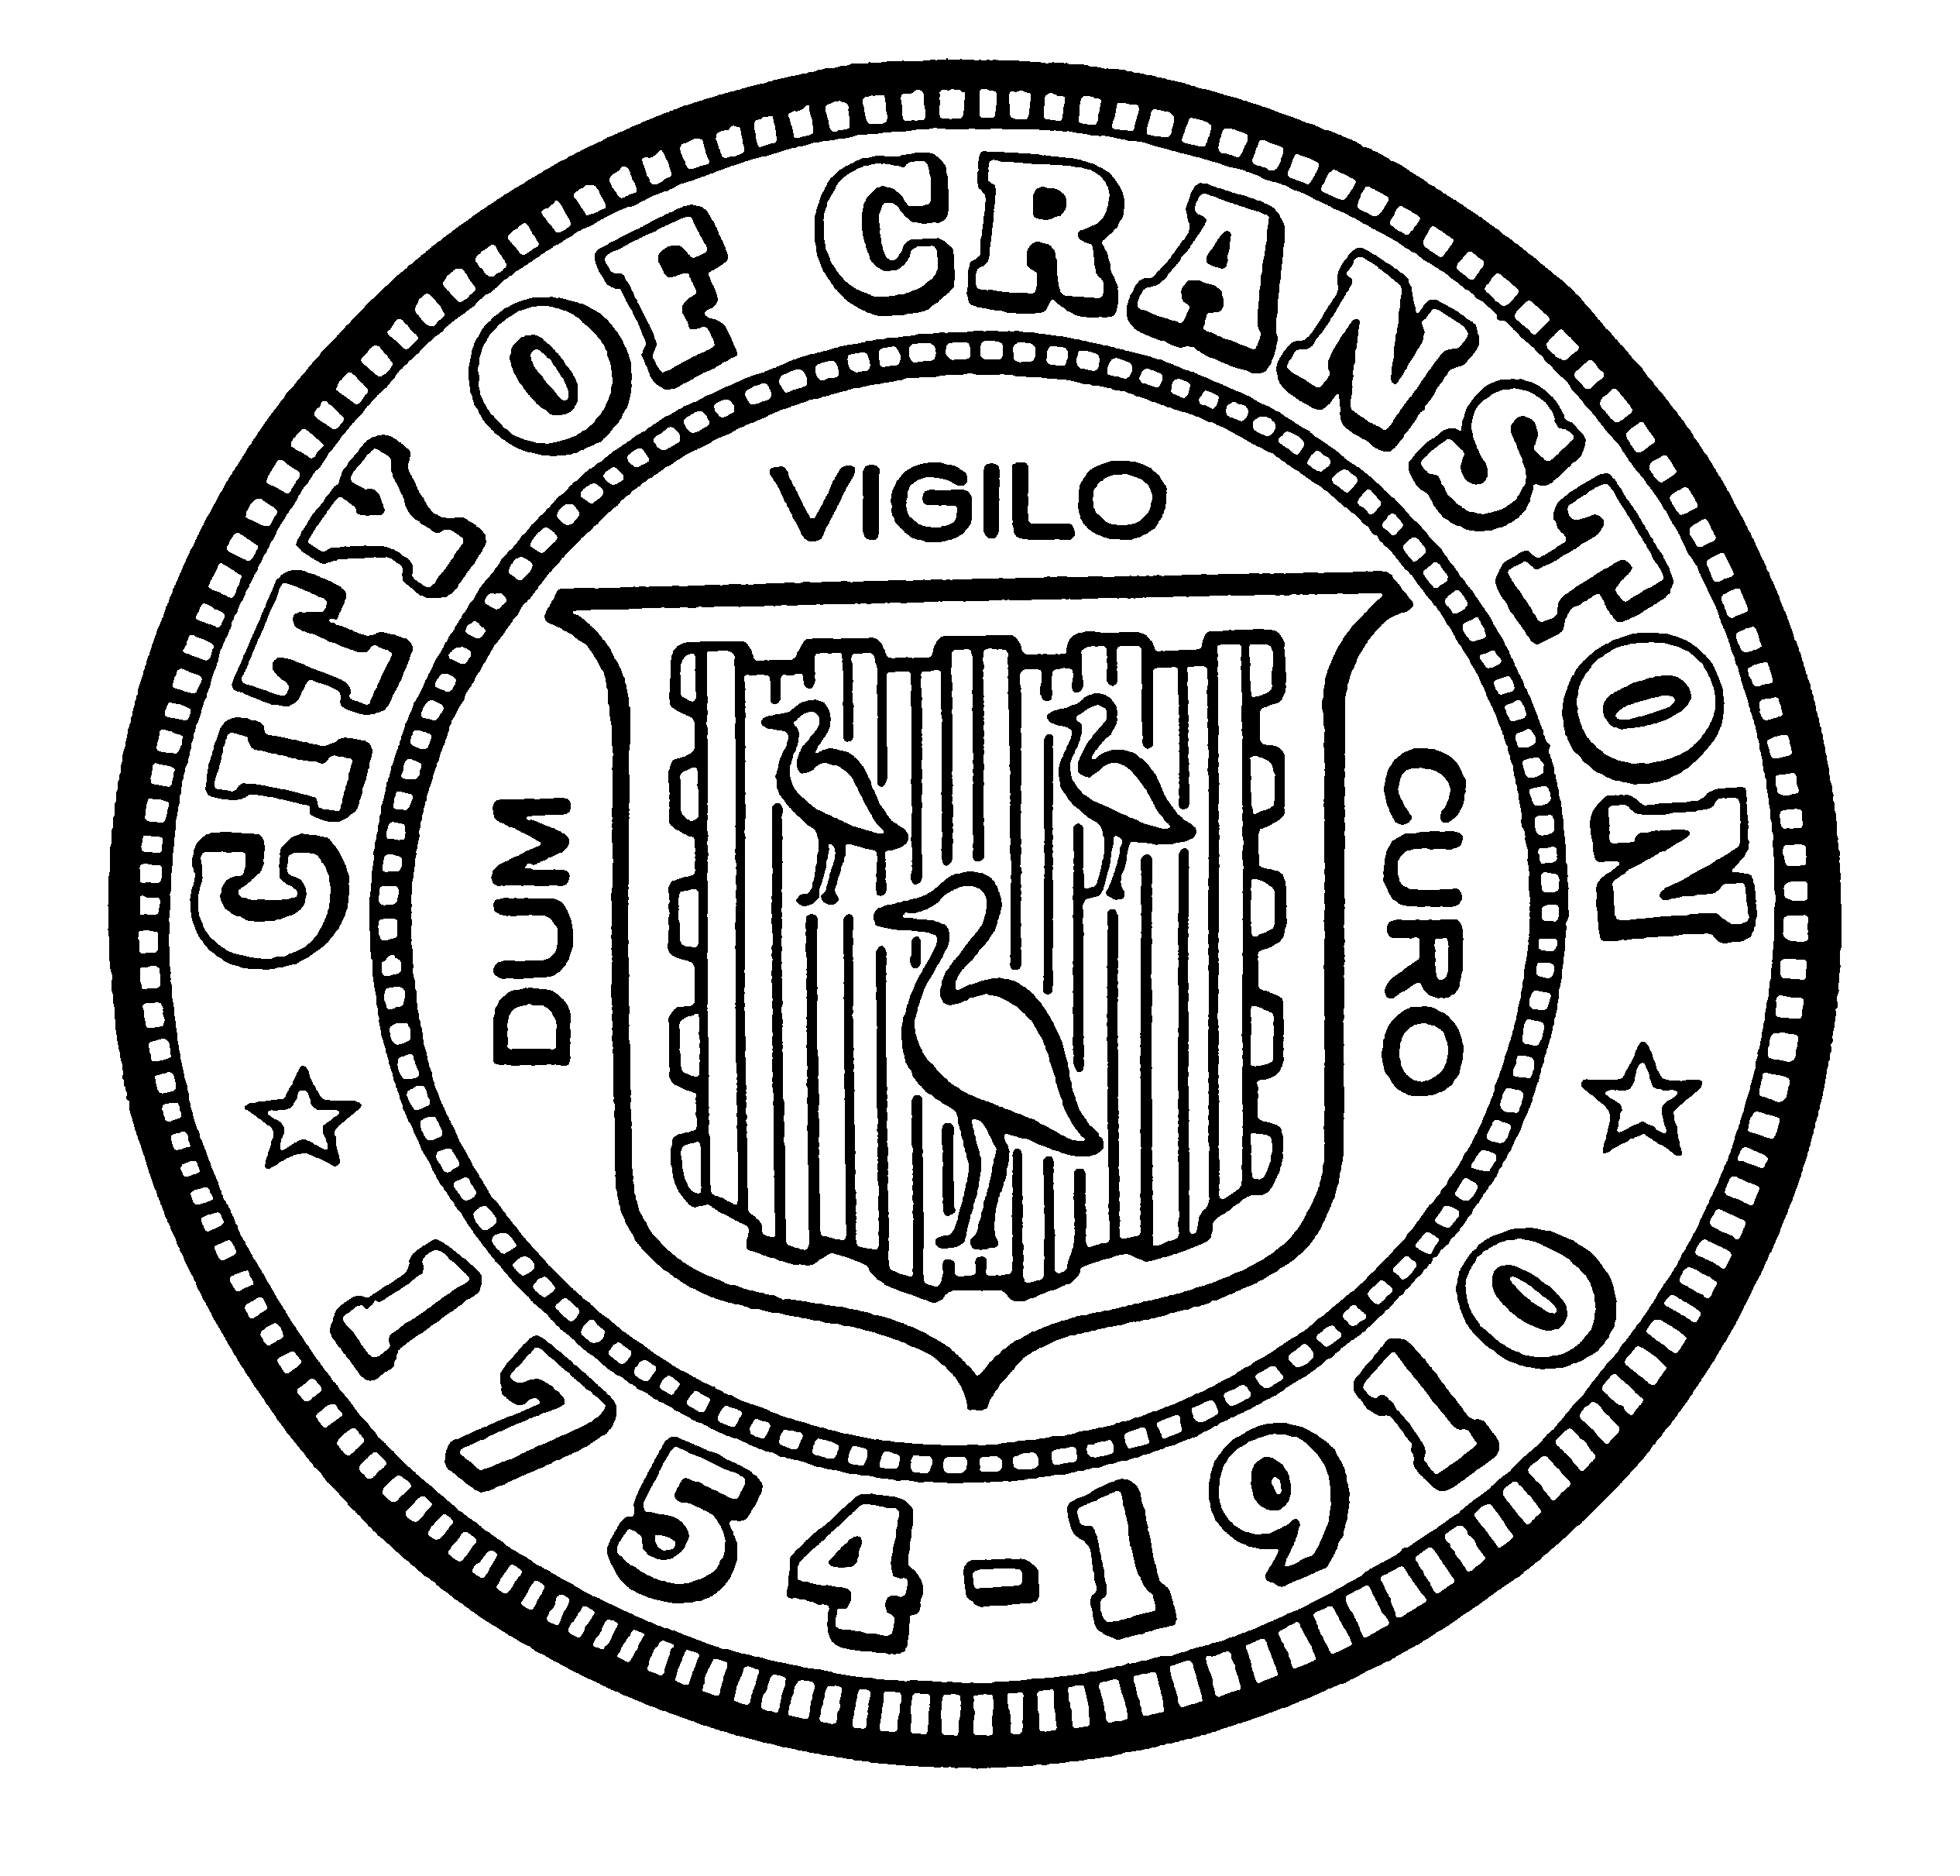

HOUSING COMMISSION
Derik Tutt Jason M. Pezzullo, Planning Director
Jeffrey P. Barone Tim G. Sanzi, Community Development
Annette Mann Bourne Robert Santurri Jr, OneCranston Health Equity Zone
Amy Rainone Joanne McGunagle, CCAP
Frank DiZoglio

WEDNESDAY DECEMBER 1, 2021 @ 5:30 P.M.

Cranston City Hall, 869 Park Avenue, Cranston

City Council Chamber

MONTHLY MEETING- OCTOBER AGENDA

- Approval of minutes of November 3, 2021 meeting
- Working Group report out
- Discussion of recommendations for use of Cranston ARPA funds to address housing needs
- Next steps

“Individuals requesting interpreter services for the hearing-impaired must notify the Office of the City Clerk at 461-1000 Ext. 3197 seventy-two (72) hours in advance of the hearing date.”

